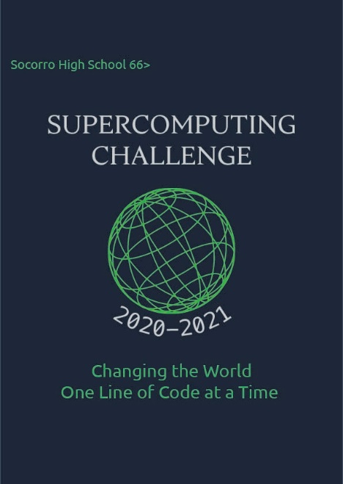

Schools that participated in the 2019-2020 Challenge
ATC, Belen High, Belen Mid, Capital, Cottonwood, Del Norte, Desert Acad, Eldorado, Gadsden, Home School, House, Jackson Mid, Logan, Los Alamos High, Los Alamos Mid, Los Lunas, Manzano, Media Arts, Melrose High, Melrose Mid, Memorial Mid, Mesilla Valley, Monte Del Sol, NMMI, NMSA, Rio Rancho Cyber, Ruidoso Mid, Sandia, Santa Fe, Sat Sci Math Acad, Socorro, Taos, Upward Bound M&S

Get excited about Engineering, Math, Science, Computation and Innovation!
TAKE THE CHALLENGE!
WIN cash, scholarships, plaques and trophies!

CHOOSE your own computational science project and join students around
New Mexico for an exciting adventure this academic year!
Mentors are available all year to help you!
REGISTER between September 1-20 at https://supercomputingchallenge.org
PLAN to attend the (virtual) KICKOFF on October 3

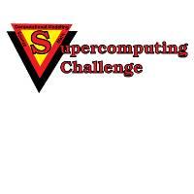

https://www.supercomputingchallenge.org consult@supercomputingchallenge.org

