Subscribe to Three Free NM STEM Lists

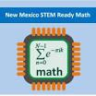 Teachers can sign up for a mailing list to receive information from the Math and Science Bureau by clicking on the following link: https://www.surveymonkey.com/r/D832LP9

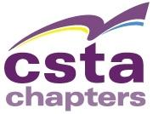 CSTA New Mexico
Computer Science Teachers Association

Open https://groups.google.com/forum/#!forum/csta-newmexico and apply to join using your email.
The link for the Facebook group is always at the end of every newsletter.

Join the NM Math & Science list. If you have a Gmail address, you can go to the google group and request to join. https://groups.google.com/forum/m/#!forum/nm-science-math.

If you have an email address other than Gmail check out

https://accounts.google.com/signup/v2?flowName=GlifWebSignIn&flowEntry=SignUp&nogm=true

