

Project Development Module

How to Submit Your AiS Challenge Abstract

AiS Challenge

Glorietta Kickoff Conference

October, 2001

Submitting Your AiS Challenge Abstract

Getting Started

Before you can officially submit your Abstract to the AiS Challenge staff, at least one member of your team must log on to the Mode machine. To do so, perform the following steps while sitting in front of a PC:

- From the “Start” menu in the lower left-hand corner of the screen select “Run …”

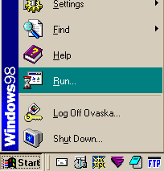

- In the text window, type in “telnet mode.lanl.k12.nm.us” and press the “OK” button.

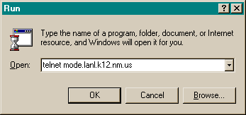

- From the telnet window, enter in your login name next to where it says “Username: ”. You can find your login name in the lower left-hand corner of your nametag.

Also enter in your SCC (SuperComputing Challenge) Password at the prompt. You can find your password in the lower right-hand corner of your nametag, although you may have changed it when you logged on earlier.

Note that your password won’t display to the screen when you type it in. This is a security precaution in case someone is looking over your shoulder!

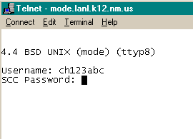

- At the Mode prompt, type the command “ls”, to list the files and folders available in your home directory (folder). You should see, among other items, a folder named “public_html”.

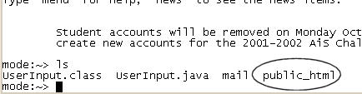

- Enter this directory by issuing the command “cd public_html” at the prompt. Note how the prompt will change to indicate you are now in the public_html directory.

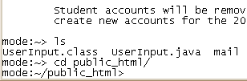

prompt changes

- Now, use the “ls” command to see the items in your public_html directory. You should see a file named “abstract.html”. This is the file that you will place the text of your actual abstract into!

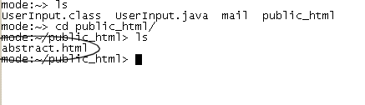

Working with the Abstract Template

The file abstract.html, is the file that you will need to edit with information about your team and team members, as well as the textual content of your actual project description (i.e. your abstract).

- At the mode prompt, type “pico abstract.html”. This will open the file for editing.

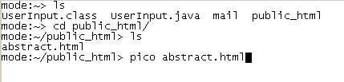

- You should obtain an interface which looks similar to the following picture. From this screen, you can edit the abstract file as indicated on the next page.

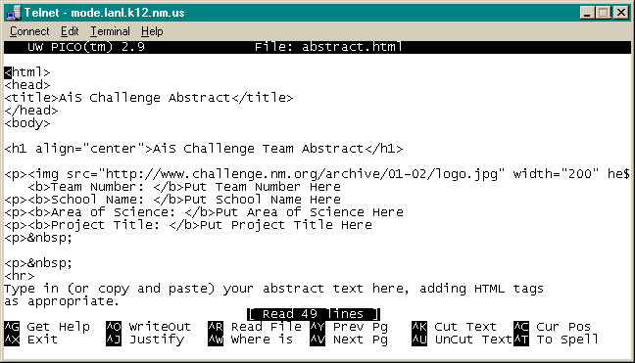

Required Information

Use the arrow keys, backspace key, and delete key to scroll through the document and edit the following information: (the next two pages visually demonstrate this …)

- Team Number
- School Name
- Area of Science
- Project Title
- Abstract
- Team Member(s) (and login names)
- Sponsoring Teacher(s) (and login names)
- Mentor(s)

You will replace this information (as seen in bold and circled on the next page) with information appropriate to your team and project. Some items to keep in mind:

- If you do not know HTML, the only thing that you need to keep in mind while entering your abstract is that you should place a paragraph tag before the start of each new paragraph you type in.

A paragraph tag looks like this: <p>

- Fill in the abstract.html file as complete as you can, but don’t worry if you are not able to remember all of the details.

A completed example is shown two pages from this page.

The abstract.html file

<html>
<head>
<title>AiS Challenge Abstract</title>
</head>
<body>

<h1 align="center">AiS Challenge Team Abstract</h1>

<p><img src="http://www.challenge.nm.org/archive/01-02/logo.jpg" width="200" height="150" align="left" border="3">
<b>Team Number: </b>Put Team Number Here
<p><b>School Name: </b>Put School Name Here
Use <p> tags in front of additional paragraphs
<p><b>Area of Science: </b>Put Area of Science Here
<p><b>Project Title: </b>Put Project Title Here
<p>&nbsp;

<p>&nbsp;
<hr>
Type in (or copy and paste) your abstract text here, adding HTML tags
as appropriate.
<hr>

<!--

FOR STUDENTS AND TEACHERS BELOW, MAKE SURE TO ENTER A VALID E-MAIL ADDRESS
WHERE YOU SEE "ch099abc@mode.lanl.k12.nm.us" or "chtabcde@mode.lanl.k12.nm.us"

DELETE ANY LINES THAT BEGIN WITH "<li>" THAT YOU DO NOT USE!

-->

<p><b>Team Members</b>
<ul>
<li><a href="mailto:ch099abc@mode.lanl.k12.nm.us">Put Team Member Name Here</a>
<li><a href="mailto:ch099abc@mode.lanl.k12.nm.us">Put Team Member Name Here</a>
<li><a href="mailto:ch099abc@mode.lanl.k12.nm.us">Put Team Member Name Here</a>
<li><a href="mailto:ch099abc@mode.lanl.k12.nm.us">Put Team Member Name Here</a>
<li><a href="mailto:ch099abc@mode.lanl.k12.nm.us">Put Team Member Name Here</a>
</ul>

<p><b>Sponsoring Teacher(s)</b>
<ul>
<li><a href="mailto:chtabcde@mode.lanl.k12.nm.us">Put Teacher Name Here</a>
<li><a href="mailto:chtabcde@mode.lanl.k12.nm.us">Put Teacher Name Here</a>
</ul>

<p><b>Project Mentor(s)</b>
<ul>
<li>Put Mentor Name Here
<li>Put Mentor Name Here
</ul>

</body>
Completed abstract.html file

<html>
<head>
<title>AiS Challenge Abstract</title>
</head>
<body>

<h1 align="center">AiS Challenge Team Abstract</h1>

<p><img src="http://www.challenge.nm.org/archive/01-02/logo.jpg" width="200" height="150" align="left" border="3">
Note the use of a <p> tag in front of the additional paragraph
<b>Team Number: </b>123
<p><b>School Name: </b>Glorieta High School
<p><b>Area of Science: </b>Biology
<p><b>Project Title: </b>Modeling Bacteria Growth
<p>&nbsp;

<p>&nbsp;
<hr>
This project will demonstrate the growth of bacteria under certain conditions. In particular, we will focus upon common household bacterias, such as E-codlum Magus.

<p>We will use a set of differential equations (namely the Borst equation) to effectively model the growth over a period of 24 hours. We hope to graph our results for easy interpretation.
<hr>

<!--

FOR STUDENTS AND TEACHERS BELOW, MAKE SURE TO ENTER A VALID E-MAIL ADDRESS
WHERE YOU SEE "ch099abc@mode.lanl.k12.nm.us" or "chtabcde@mode.lanl.k12.nm.us"

DELETE ANY LINES THAT BEGIN WITH "<li>" THAT YOU DO NOT USE!

-->

<p><b>Team Members</b>
<ul>
<li><a href="mailto:ch123abc@mode.lanl.k12.nm.us">Allen Cunningham</a>
<li><a href="mailto:ch123def@mode.lanl.k12.nm.us">Debra Fields</a>
<li><a href="mailto:ch123ghi@mode.lanl.k12.nm.us">George Ijo</a>
</ul>

<p><b>Sponsoring Teacher(s)</b>
<ul>
<li><a href="mailto:chtjmarti@mode.lanl.k12.nm.us">Mr. Martinez</a>
</ul>

<p><b>Project Mentor(s)</b>
<ul>
<li>Dr. Smith from UNM
</ul>

</body>

Viewing Your Abstract

After you have finished editing the abstract.html file, hold down the control key and type the letter “o”. This will “WriteOut”, or save, your changes to this file.

Note: Simply press “Enter” when it asks you for the “file name to write”

Next, hold down the control key and type the letter “x”. This will exit the “pico” text editor and return you to the mode prompt.

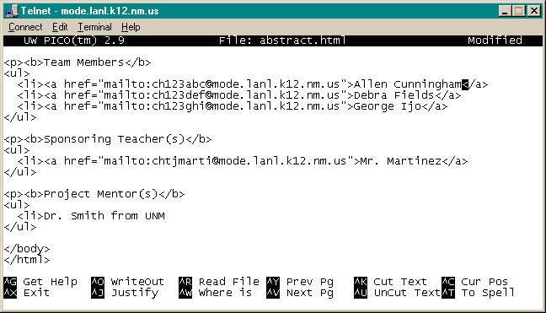
Save Changes
Exit Pico

The file that you have just edited is a web page – to view what your online abstract will look like, open a web browser and enter the following URL:

http://mode.lanl.k12.nm.us/~ch123abc/abstract.html

where “ch123abc” is your login name.

If you see errors, re-edit the file by typing the command “pico abstract.html” at the mode prompt.
The Final Steps – Submitting Your Abstract

Now, while you are still in your public_html directory, issue the command
“submit abstract.html”. This sends your abstract to the AiS Challenge staff.

You should see the following confirmation message:

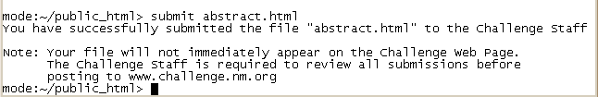

A week or so after the kickoff conference, you will see your abstract available off of the main challenge web page at www.challenge.nm.org

Finally, type “exit” at the mode prompt to log off from the machine.

