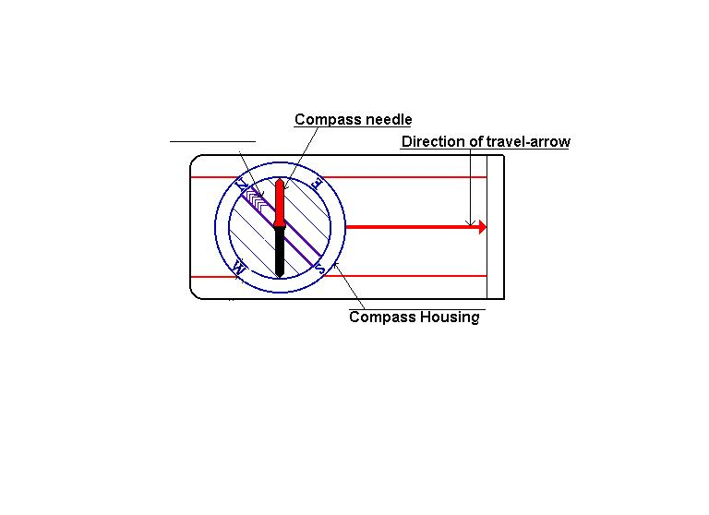

Orienteering Teacher Cheat Sheet

You see this red and black arrow? We call it the compass needle, **the red part of it is always pointing towards the earth's magnetic north pole.**

For teaching purposes we will call the red end of the needle RED FRED.

The Orienting arrow we will call the SHED.

RED FRED

You see this red and k

THE SHED

SET HEADING HERE

The Heading is based on a circle and a total of 360°. Have the students set the heading by turning the dial on the compass to 325°. Check everyone to make sure they have the correct heading. Try a few more if they haven’t got it.

Next, the students need to learn how to put RED FRED IN THE SHED.

Have students hold the compass in their hand. They will have to hold it quite flat, so that the compass needle can turn. Then have them turn themselves, their hand, the entire compass, just make sure the compass housing doesn't turn, and turn it until the compass needle is aligned with the lines inside the compass housing by putting red fred in the shed. Students will try to move just the compass around in their hand and not move with it. CORRECT this mistake early because it is the key to everything.

Lastly, the students need to learn how walk with the compass so that they do not end off course.

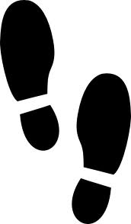This is where the pacing comes in. Students should walk a stride length equivalent

Of a 12 inch stride from tip to

heel

This would equal 1 in their counting of steps.

Practice setting the heading, putting RED FRED in the SHED as a group and pacing as a group. That way you can tell who doesn’t have the concept.

Practice Challenges: 325 ° 3 paces

0° 2 paces

200 ° 4 paces

45 ° 1 pace

Remind students when they get their course they will set the heading on the compass (degrees), and then put red fred in the shed. They will walk in the direction of the travel arrow. As they walk, Red Fred can not leave the shed or they will end up off course. The number of steps/paces tells them how far to travel before arriving at their destination.

To avoid getting off the course, make sure they look at the compass quite frequently, say every hundred meters at least.

Course Sheet Sample

320 ° 42 paces

Adapted from <http://www.learn-orienteering.org/old/lesson1.html>