Simple Epidemic Model:

In this model, we will create a world where a disease spreads through a population. The key points to the model will be:

- Agents with a red color will have the disease, and healthy agents will be green.

- Agents will catch the disease by colliding with an agent who is already sick.

- A sick individual will have a chance to recover at every step.

These three core ideas can be seen as modules to construct the program. To do so, we will need to:

- Create agents in the world.
- Make the agents move.
- Make some of those agents sick.
- Make the disease spread via collision.
- Make the agents recover.
- Make a line graph that displays the count of sick and infected agents.
- Expand the model and make it your own!

Follow the instructions below for a detailed piece-by-piece guide for making this model.

1). Setup Procedure:
We want to create some turtles, scattered randomly around the world, that will be green to show they are healthy.

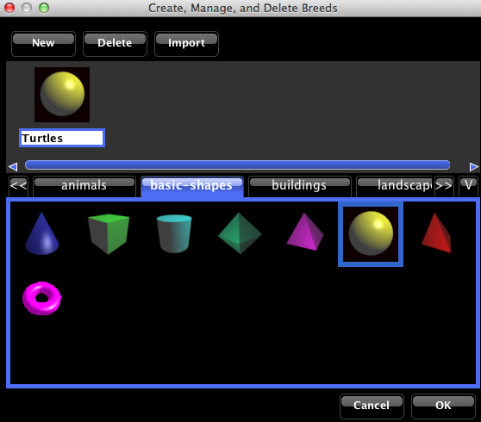
1a). Change the turtles’ breed to the sphere. We do this because the sphere has a single, solid color.

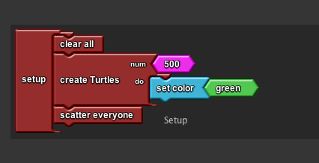
1b). Create 500 turtles.*

1c). Set the color of the turtles to green

1d). Scatter all of the agents.

*Note: We use the “create turtles / do” block because we want to set the turtles’ color to green. In almost all cases, the create turtles / do block is preferred over the simple create turtles block

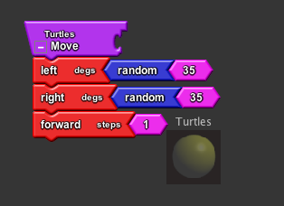
2). Make the turtles move by giving them a movement procedure.*

*Here we use a wiggle procedure to make the turtles move throughout the terrain, but experiment with different patterns of movement to see how it effects the spread of the disease.

3).
Make a run-once button named “Infect” that makes some percentage of the turtles turn red using the following rule:

“Roll a 10-sided die. If the number thrown is a one, I will turn red”*

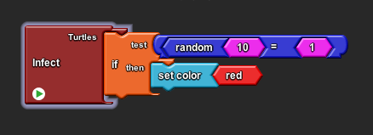
*This gives a 10% chance that any turtle will turn red when Infect is pressed. Experiment with different starting percentages of infection.

4). Make turtles collide with each other using the following rule:

“If the color of the turtle that runs into me is red, I myself will turn red.”
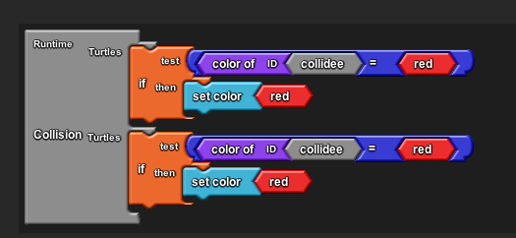
Both of the sockets on the Collisions block need this code to run properly.

5). Give the turtles a procedure that gives them some probability, at every step, of turning back to green/healthy using the following rule:

“Roll a 10 sided die. If the number thrown is a one, I will turn green”
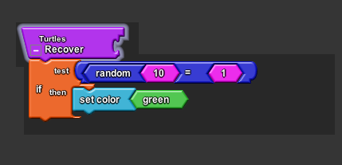

6). Add in a line graph that counts turtles that are green and turtles that are red. Be sure to name the line graph and the data it is displaying.*

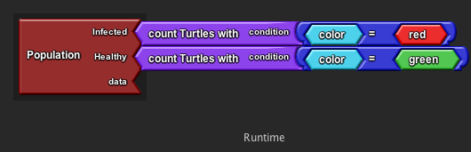

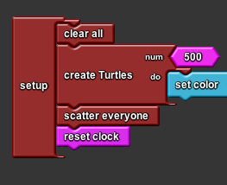
*Note that by adding a line graph, a “reset clock” block should be added to the Setup procedure to clear and reset the line graph every time setup is pressed.

7). Expanding the Model

You can expand and customize this base model to suit a wide variety of projects. Some simple expansions might come by asking questions about the model, such as:

“What would happen if we change the rate of recovery while the model is running?”

7a). To answer this question, we can add a slider to the model that we can change while the model is running:

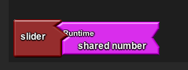
- Take the “slider” block from the Setup & Run drawer. (place it in the Everyone column since it is a “global variable”: all the agents know and share this variable.

- Attach the Shared Number block from the Variables drawer.

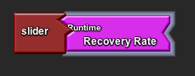

- Rename “Shared Number” to “Recovery Rate” or some other informative description.

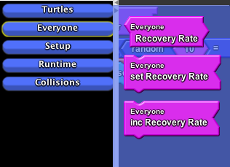

- In “Everyone” bin in My Blocks, find the “Recovery Rate” (or whatever you have named it) block.

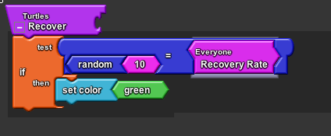
- Replace the 10 on the right side of the “Random 10 = 10” equation with Recovery Rate.

