Supercomputing Challenge Four C’s

Critical thinking
Problem statement about self-chosen topic
Research
Weighing feedback
Creating what if scenarios
Comfortable with ambiguity

Collaboration
Teamwork
Project and time management
Working with professionals
Building consensus
Leadership skills

Communication
Oral presentations
Technical writings
Speaking with mentors
Speaking your mind

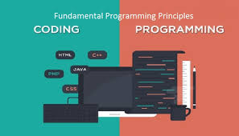
Coding
Decide whether to use agent based,
mathematical or parallel programming
Ability to explain program
Creating algorithms, agents
Problem Solving
Creativity

