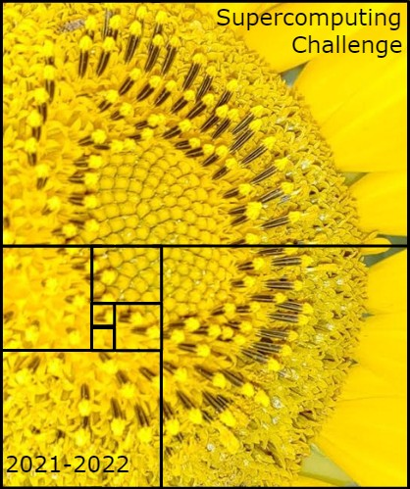
Schools that participated in the 2020-2021 Challenge
AIMS@UNM, Capital, Cleveland, Clovis High Early College, Corona, Cottonwood, Del Norte, Eldorado, Harrison Mid, Jackson Mid, La Cueva, Los Alamos High, Los Alamos Mid, Los Lunas, Manzano, Melrose High, Mescalero, Mesilla Valley, Monte Del Sol, NMMI, NMSA, Rio Rancho Cyber, San Juan College High, Sandia Prep, Santa Teresa, Sat Sci Math Acad, St. Thomas Aquinas, Socorro, Taos

Get excited about Engineering, Math, Science, Computation and Innovation!
TAKE THE CHALLENGE!
WIN cash, scholarships, plaques and trophies!

CHOOSE your own computational science project and join students around
New Mexico for an exciting adventure this academic year!
Mentors are available all year to help you!
REGISTER in September at https://supercomputingchallenge.org
PLAN to attend the (virtual) KICKOFF on October 9

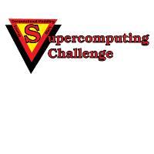

https://supercomputingchallenge.org consult@supercomputingchallenge.org

