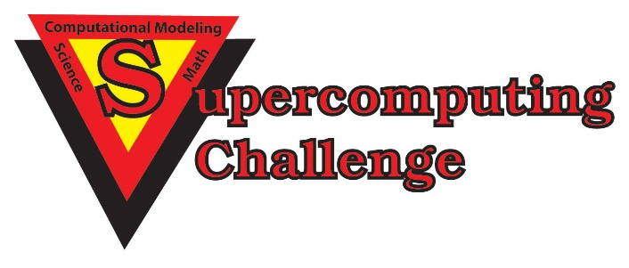

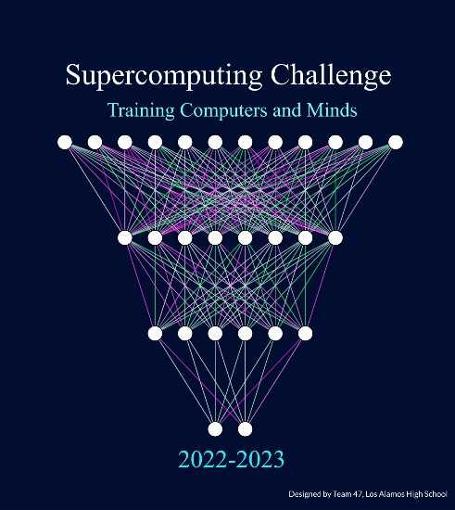

Schools that participated in the 2021-2022 Challenge
Capital, Cleveland, Corona, Cottonwood, Del Norte, Eldorado, Harrison Mid, Heizer Mid, Jackson Mid, Justice Code, La Cueva, Los Alamos High, Manzano, Melrose, Monte Del Sol, Mountain Elem, NMMI, NMSA, Rio Rancho Cyber, San Juan College High, Sandia Prep, Santa Fe High, Santa Fe Prep, St. Thomas Aquinas, Taos, Truman Mid

Get excited about Engineering, Math, Science, Computation and Innovation!
TAKE THE CHALLENGE!
WIN cash, scholarships, plaques and trophies!

CHOOSE your own computational science project and join students around
New Mexico for an exciting adventure this academic year!
Mentors are available all year to help you!
REGISTER in September at https://supercomputingchallenge.org
PLAN to attend the KICKOFF on October 22-23 at NM Tech in Socorro.

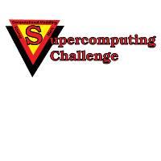

https://supercomputingchallenge.org consult@supercomputingchallenge.org

