

**PRIMARY PARTNERS**

Los Alamos National Laboratory

New Mexico Consortium

Triad National Security

**PLATINUM PARTNERS**

Sandia National Laboratories

**GOLD PARTNERS**

Westwind

**SILVER PARTNERS**

The Encantado Foundation

Gulfstream Group/bigbyte.cc

LANL Foundation

META

PNM

**BRONZE PARTNERS**

Air Force Research Laboratory

Descartes Lab, Inc

HPE/Carahsoft

Holmans

Intel

New Mexico Technology Council

NM Technology in Education

Simtable, LLC

**EDUCATIONAL PARTNERS**

CCL/NetLogo

Central NM Community College

CNM Ingenuity, Inc

Eastern New Mexico University

MIT StarLogo

New Mexico EPSCoR

New Mexico Highlands University

New Mexico Institute of

Mining and Technology

New Mexico Public Ed Dept

New Mexico State University

Northern New Mexico College

San Juan College

Santa Fe Community College

University of New Mexico

**Friends of the Challenge**

Abba Technologies

Computer Science Alliance

Dr. Shaun Cooper, NMSU

Daniel and Mel Fuka

Clint Hubbard

Maximo Lazo

Irene Lee/Roger Critchlow

Merrick

NM Network for Women in

Science and Engineering

Fred Voss

Windspirit Therapeutic Massage

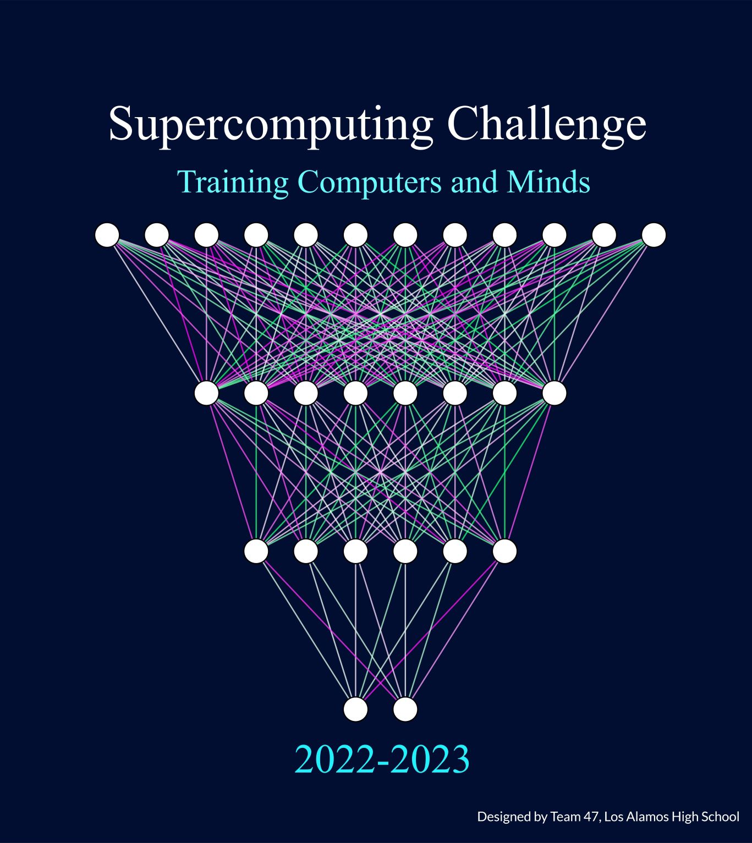

**P. O. Box 91824**

**Albuquerque, NM 87199**

**­­­­­­­­­­­­­­­­­­­­­­­­­­­­­­­Phone: (505) 220-7273 ■ E-mail: consult@supercomputingchallenge.org**

No direct or indirect benefit shall accrue to you the donor or to any related third party as a result of your gift. The New Mexico Supercomputing Challenge is a registered nonprofit 501(c)3 organization.