2009-2010
Supercomputing Challenge
Schools that participated in the 2008-2009 Challenge

Aguilar, AIMS@UNM,
Albuquerque Academy,
Artesia, Aspen, Barranca,
Bloomfield, Bosque School, Capshaw, Chaparral, Desert Academy, ENIPC Upward Bound, Espanola, Freedom, Hope Christian,
Jackson, La Cueva,
Los Alamos High, Los Alamos Mid, Manzano,
McCurdy, Melrose,
Monte del Sol, Navajo Prep, NNMC, Nuestros Valores,
Rio Rancho, Rio Rancho Mid-High, Sandia Prep,
Santa Fe, Santa Fe Indian School, Silver, Socorro

Get excited about Engineering, Math, Science, Technology and Innovation!

TAKE THE CHALLENGE!

Winners receive cash, scholarships, computer equipment,
plaques and trophies.

Choose your own computational science project and join students around New Mexico for an exciting adventure this academic year!

To participate in the 20th Annual Supercomputing Challenge, see:

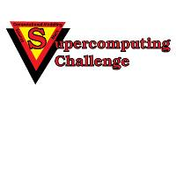
http://www.challenge.nm.org consult@challenge.nm.org

