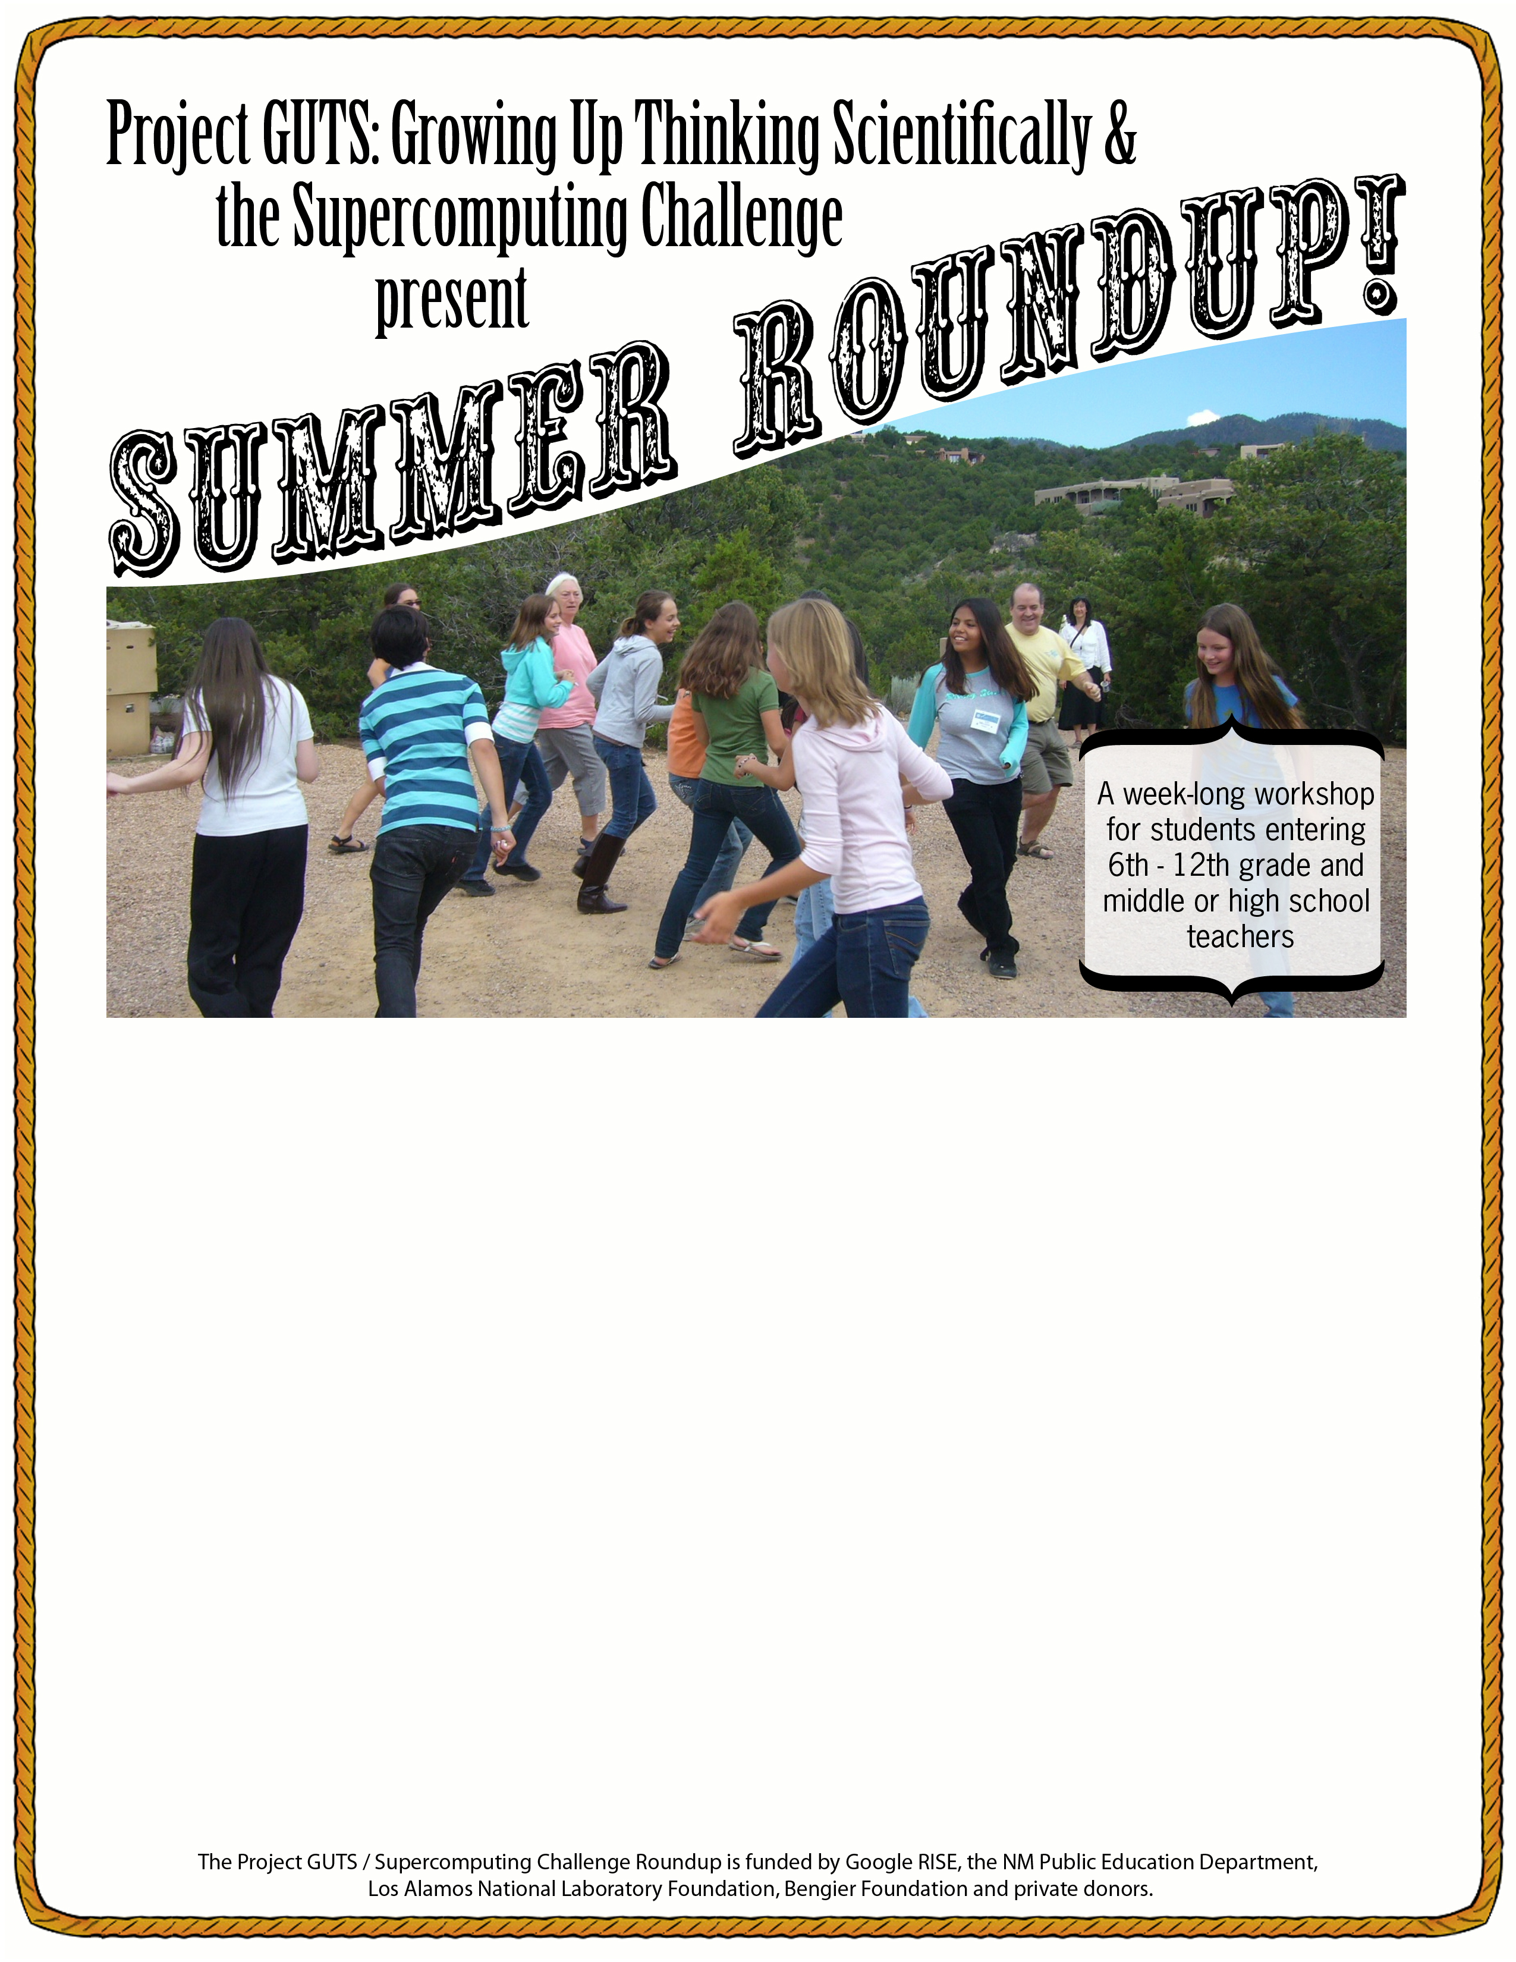
What: The Summer Roundup introduces students and their teachers to the Project GUTS and Supercomputing Challenge programs. During this free workshop students and teachers will explore new concepts in science, technology, engineering and mathematics, develop computer skills, and get access to the very latest technology. Participating teachers will also learn about how to start a Project GUTS club and sponsor a Supercomputing Challenge team.

Why: Project GUTS and the Supercomputing Challenge offer a unique opportunity for students and their teachers to learn about computer modeling and how it is used by scientists in cutting-edge research. In addition, our materials are aligned with NM State Science and Math Standards and complement school day learning with hands-on and computer-based activities that promote critical thinking and inquiry skills.

When: Monday, June 21, 2010 - Friday, June 25th, 2010
Students will attend from 9am – 12 noon. Dismissal at noon.
Teachers will attend from 9am – 3pm with a lunch break at noon.

Where:

Register at: http://www.surveymonkey.com/s/WQCBQL7

Contact Celia Einhorn, celia.einhorn@gmail.com or 505-321-9925 for more info

