2012-2013
Supercomputing Challenge
Schools that participated in
Los Alamos High, Los Alamos Mid, Manzano,
Mayfield, Melrose, Mesa Mid, Miyamura, Monte del Sol, Navajo Prep, NMSA,
Onate, Picacho Mid, Pinon Elem, Quemado, Red Mountain, Rio Rancho Cyber Acad, Roberson, Sandia Prep, Santa Fe High, Santa Fe Indian, Sarracino Mid, Saturday Sci&Math Acad, Shiprock, Sierra Mid, Socorro, St. Pius X, Taos, The Ask Acad, The MASTERS Program, Zuni
the 2011-2012 Challenge
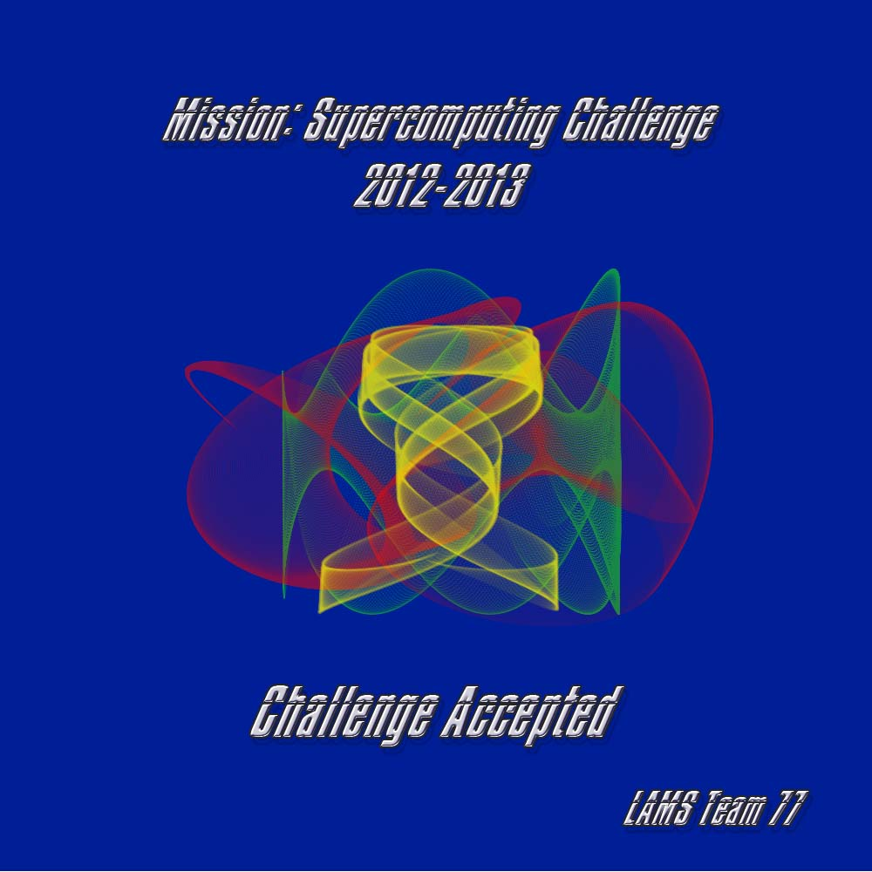
ATC, AIMS@UNM, Alamogordo,
Albuquerque High,
Aldo Leopold High,
Artesia, Aspen, Bernalillo, CEPi1, Chaparral, Cleveland, Desert Academy, Down to Earth, Edgewood, Escalante, Espanola, Freedom, Grants, Hatch, Jackson, La Cueva, Las Cruces, Little Earth,

Get excited about Engineering, Math, Science, Computation and Innovation!
TAKE THE CHALLENGE!
WIN cash, scholarships, plaques and trophies!

CHOOSE your own computational science project and join students around
New Mexico for an exciting adventure this academic year!
Mentors are available to help you!
REGISTER between September 1-20 at http://supercomputingchallenge.org
PLAN to attend the KICKOFF at New Mexico Tech October 13-14
To participate in the 23rd Annual Supercomputing Challenge, see:

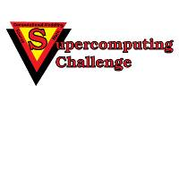
http://supercomputingchallenge.org consult@challenge.nm.org

