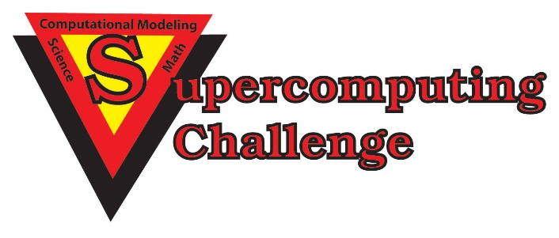

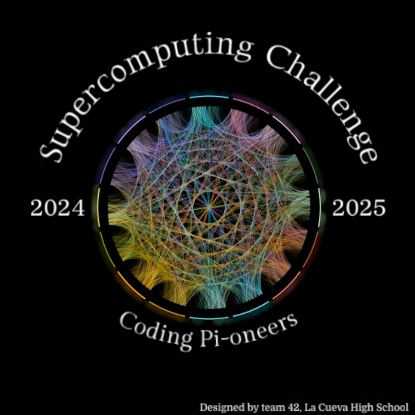

***Schools that participated in the 2023-2024 Challenge***

***ATC, Alb Acad, Capital, Harrison Mid, Justice Code, La Cueva, Los Alamos High, Los Alamos Mid, McKinley Mid, Monte Del Sol, New Futures, NM Acad for Media Arts, NMSA, Santa Fe Prep,***

***St. Thomas Aquinas, Truman Mid, Tucumcari, V. Sue Cleveland***

**Get excited about Engineering, Math, Science, Computation and Innovation!**

***TAKE THE CHALLENGE!***

**WIN cash, scholarships, plaques and trophies!**

**CHOOSE your own computational science project and join students around**

**New Mexico for an exciting adventure this academic year!**

**Mentors are available all year to help you!**

**REGISTER in September at** [**https://supercomputingchallenge.org**](https://supercomputingchallenge.org)

**PLAN to attend the KICKOFF on Oct 26-27 at NM Tech in Socorro.**

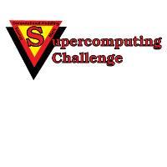

[**https://supercomputingchallenge.org**](https://supercomputingchallenge.org)[**consult@supercomputingchallenge.org**](mailto:consult@supercomputingchallenge.org)