JMJL Victoria Reichow
Rationale:
I want to understand the impact on the Great Barrier Reef if an important aquatic species disappeared.

Question or Problem:
What would be the impact to the surrounding ocean ecosystem within the Great Barrier Reef, if the population of an important aquatic species decreased or completely disappeared?

Goals:
What would be the impact to the surrounding ocean ecosystem within the Great Barrier Reef, if the population of an important aquatic species decreased or completely disappeared? What is considered a huge contributor to the health of the reef’s ecosystem, and what can humans do to maintain a healthy ecosystem at the Great Barrier Reef?

Expected Outcomes:
Initially, I believed the white tipped reef sharks had the greatest impact on the ecosystem of the Great Barrier Reef. They are one of the most well known reef sharks because they are seen the most in reefs. However, they do not play a vital role in the ecosystem of the Great Barrier Reef.

Hypotheses:
I believe sharks play an important role in the ecosystems of the Great Barrier Reef, but some are endangered because of water pollution. If their population declines, or they go extinct, it could cause the reef to become bleached.

Report:
The Great Barrier reef is an underwater ecosystem that is home to many sea creatures. The reef is found off the coast of Australia in the sunlight zone. It is home to many sharks like the white tip reef shark and the whale shark, which both play an important role in the ecosystem.

Whale sharks are the largest sharks in the world. A full grown whale shark can weigh up to 41,000 pounds. They are filter feeders that can gulp in more than 7,000 gallons of water a day. Whale sharks were first discovered off the coasts of South Africa. Whale sharks were first discovered in 1828, and became endangered in 2016 The world wide population of whale sharks is currently about 7,100.

Within the food chain of the Great Barrier Reef, whale sharks are a secondary consumer. Whale sharks eat primary consumers, such as plankton. Plankton get their food from the sun, water, and carbon dioxide. Whale sharks keep the balance of the plankton in check at the reef by eating the plankton. This means that whale sharks have the greatest impact on the ecosystem and life of the Great Barrier Reef by eating zooplankton and other species of plankton, which is important because the red crowned starfish, an enemy of the reef, also eats plankton.

My hypothesis was that sharks are endangered because of water pollution, but specifically, whale sharks are endangered because of overfishing and pollution. People of China, Taiwan, and Singapore are overfishing whale sharks. The most common reason for why whale sharks are being fished is for their fins and meat. They use the fins in soup and the meat as protein. Sewage pollution and plastic pollution are affecting reefs such as the Great Barrier Reef, but the pollution doesn’t seem to be impacting the population of the whale shark like overfishing is.

The impact of whale sharks disappearing would cause the Great Barrier Reef to become bleached. First, the plankton would overpopulate the reef because the whale sharks would no longer eat them as their main source of food. Plankton is also the main source of food for the red crowned starfish, which is the enemy of the reef. As plankton levels increase, so would the population of red crowned starfish.

If the red crowned starfish permanently lived in the Great Barrier reef at elevated population levels, it would have a long term effect on the reef’s ecosystem. The red crowned starfish also eats coral as a main source of food. As their populations increase, so would their consumption of coral. If they consume the coral, some sections of the reef would die, while other sections would become completely bleached, greatly impacting the other aquatic species .

My code displays what would happen if whale sharks continued to disappear. The whale sharks are represented as white fish. The green dots represent plankton. Invisible birds represent the overfishing issue described above. As the white fish disappear, the population of the green dots increases. The red stars represent the red crowned starfish. As more green dots appear, more red stars appear, eating the green dots.

If whale sharks become critically endangered, restoring their population can bring everything back in balance. Every organism within the reef plays an important role in the world. If one organism in an ecosystem becomes extinct, it impacts the entire ecosystem. We can help the whale sharks at the Great Barrier Reef by not buying any products made with or from whale sharks. We can also sign petitions that make it illegal to fish or trade whale sharks. Finally, we can educate people of the countries who eat whale sharks about alternative meat sources.

As we learn how to retain a healthy ecosystem at the Great Barrier Reef, we can replicate this process to determine how we can save other reefs, like the Hawaiian reef. Studying how the ecosystem thrives, is the key to unlocking how humans may be impacting it, by overfishing or pollution.

Materials:
NetLogo coding software

Procedures:
My code displays what would happen if whale sharks continued disappearing. The whale sharks are represented as white fish. The green dots represent plankton. Invisible birds represent the overfishing issue described above. As the white fish disappear, the population of the green dots increases. The red stars represent the red crowned starfish. As more green dots appear, more red stars appear, eating the green dots. Eventually, the stars overpopulate the reef.

breed [dots dot]
breed [sharks shark]
breed [birds bird]
breed [stars star]
turtles-own [health]
to setup
clear-all
ask patches
[
set pcolor blue
]
create-stars 3
[
set shape "star"
set color red
set health random 5
set size health / 2
setxy random-xcor random-ycor
]
create-dots 10
[
set shape "dot"
set color green
set health random 5
set size health / 2
setxy random-xcor random-ycor
]

create-birds 7
[
set shape "bird"
hide-turtle
set health random 1
setxy random-xcor random-ycor
]
create-sharks 10
[
set shape "fish"
set color white
set health random 50
set size health / 10
setxy random-xcor random-ycor
]
end
to mv
rt random 45
lt random 45
fd 1
end
to grow
set health health + .01
if ( health > 2 )
[
set health 2
]
set size health
end
to go
ask dots
[
grow
]
ask dots
[
dot-reproduce
]

ask dots
[
mv
]
ask stars
[
mv
set health health - .001
]
ask stars
[
star-reproduce
]
ask sharks
[
mv
]

ask sharks
[
if any? dots-here
[
ask dots-here
[
die
]
]
]

ask birds
[
if any? sharks-here
[
ask sharks-here
[
die
]
]
]

end

to dot-reproduce
ask dots
[
if (health > 1.8)
[
set health health / 2
hatch 2
]
]
end

to star-reproduce
ask stars
[
if (health > 0.7)
[
set health health / 2
hatch 3
]
]
end

Potential Risks:
Minimal risks

Data Analysis:
Created a simulator using NetLogo coding software.

Results:
My data graphs represent the population of the decline in whale sharks, and the increase in red crowned starfish at the Great Barrier Reef. The population of the whale shark is an estimate based on a 2011 study using a combination of mark-recapture and sighting data. Similarly, the population of red crowned starfish is an estimate based on surveys from Cooktown and Cairns, which are concentrated outbreak regions. There is no data on the growth rate, so an assumption of 2% is being made.

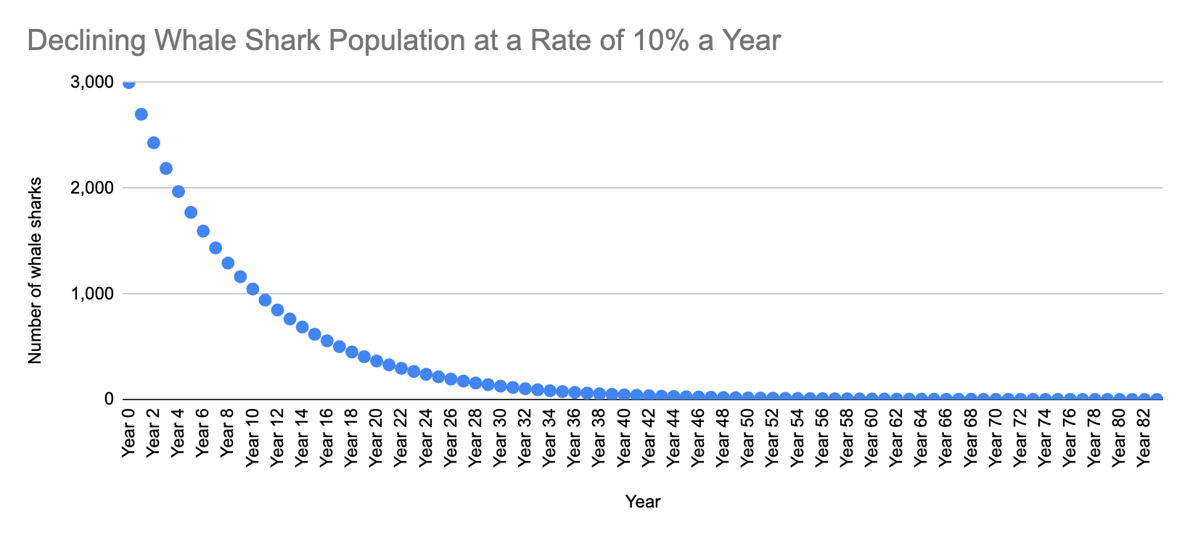

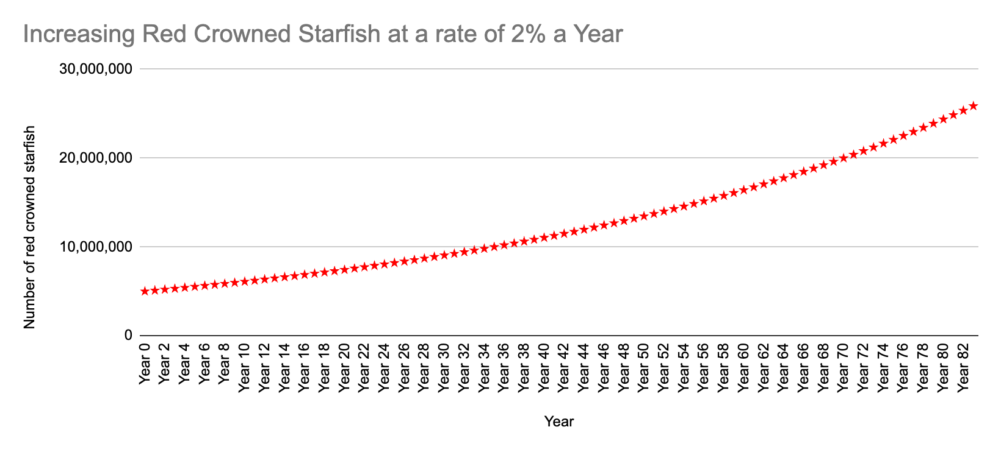

Conclusion:
The impact of whale sharks disappearing would cause the Great Barrier Reef would become bleached. First, the plankton would overpopulate the reef because the whale sharks would no longer eat them as their main source of food. Plankton is also the main source of food for the red crowned starfish, which is the enemy of the reef. As plankton levels increase, so would the population of red crowned starfish.

Bibliography:

Last name | First name | Title | City of publication | Publisher | Publication date
Shea | Therese | The Great Barrier Reef | New York, NY | The Rosen Publishing Group | 2007
Shiffman | David | Why Sharks Matter | Baltimore, MD | Johns Hopkins University Press | 2022
Klimley | Peter | The Secret Life of Sharks | New York, NY | Simon and Schuster | 2003
Gutnik | Martin | The Great Barrier Reef | Austin, TX | Raintree Steck-Vaughn | 1995
Franchino | Vicky | Getting to Know our Planet Great Barrier Reef | Ann Arbor, MI | Cherry Lake | 2016
Wintner | Robert | Reef Libre | Lanham, MD | Taylor Trade | 1992
Ebert | David | A Pocket Guide to Sharks of the World | Princeton, NJ | Princeton University Press | 2015
Hutchinson | Stephen | Ocean A Visual Guide | Sydney Australia | Firefly Books | 2005
Veron | J.E.N | A Reef in Time | Cambridge, Ma and London, England | Harvard University Press | 2008
Author | Date Created | Website Name | Name of Sponsor Cite | Internet Address
Destiny Uruchima | April 27,2020 | Change.org |  | https://www.change.org/p/school-help-save-whale-sharks?source_location=search
Abaya, L., T. Wiegner, J. Beets, S. Colbert, K. Carlson, and K.L. Kramer | April 9,2021 | reefresilience.org | sciencedirect.com | https://reefresilience.org/article-summaries/spatial-distribution-of-sewage-pollution-on-a-hawaiian-coral-reef/
Animal Factsheets/Plankton | 10/9/19 | australian.museum |  | https://australian.museum/learn/animals/plankton/
Source | Date Accessed | Prompt
Bard, Google AI. | December 21,2023 | What rate are whale shark population decreasing each year at the great barrier reef
Bard, Google AI. | December 21,2023 | How many whale sharks are at the Great Barrier Reef
Bard, Google AI. | December 21,2023 | Number of red crowned starfish at the Great Barrier Reef
Bard, Google AI. | December 21,2023 | What rate is their population increasing each year

